**Q-1**

1>C:\Users\jain2a7\Desktop\Week2Exercise2Broken\Week2Exercise2Broken\ExploreCalifornia.Monolith\DataAccess\ToursRepository.cs(39,2,39,2): error CS1513: } expected

Ans. Added Braces at the end of the method

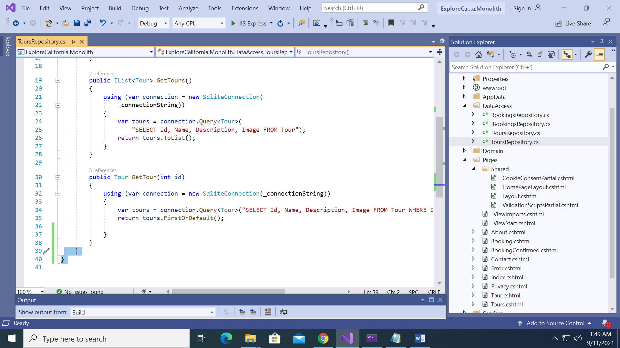

**Q-2**

1>C:\Users\jain2a7\Desktop\Week2Exercise2Broken\Week2Exercise2Broken\ExploreCalifornia.Monolith\Domain\Tour.cs(7,46,7,47): error CS8180: { or ; or => expected

**Ans**.

Added Semicolon after set in line 7

**public string Description { get; set; }**

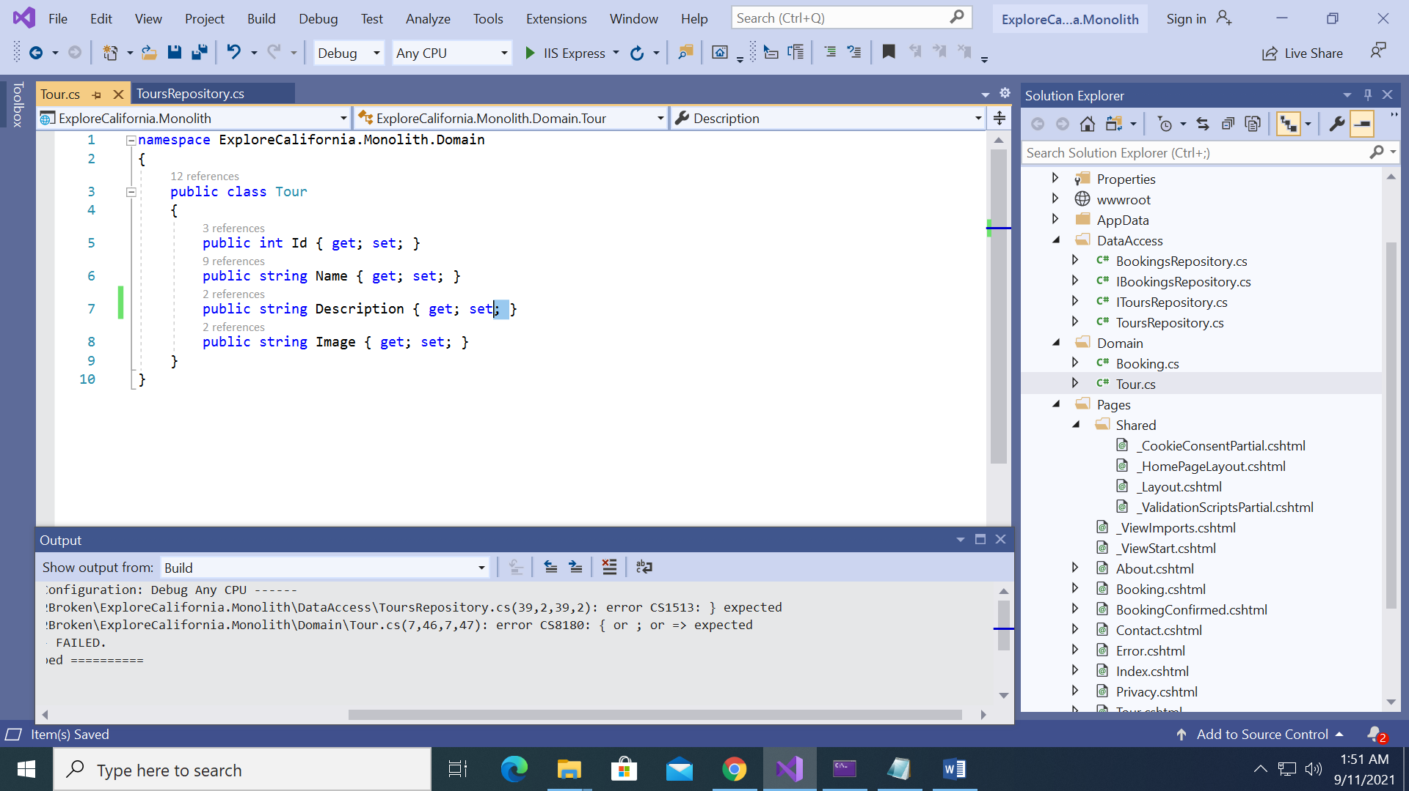

**Q-3**

1>CSC : error CS5001: Program does not contain a static 'Main' method suitable for an entry point

1>C:\Users\jain2a7\Desktop\Week2Exercise2Broken\Week2Exercise2Broken\ExploreCalifornia.Monolith\DataAccess\BookingsRepository.cs(22,67,22,71): error CS1061: 'Booking' does not contain a definition for 'name' and no accessible extension method 'name' accepting a first argument of type 'Booking' could be found (are you missing a using directive or an assembly reference?)

**Ans**.

Capitalized name to Name to get the right reference

**new { TourId = booking.TourId, Name = booking.Name, Email = booking.Email, Transport = booking.Transport });**

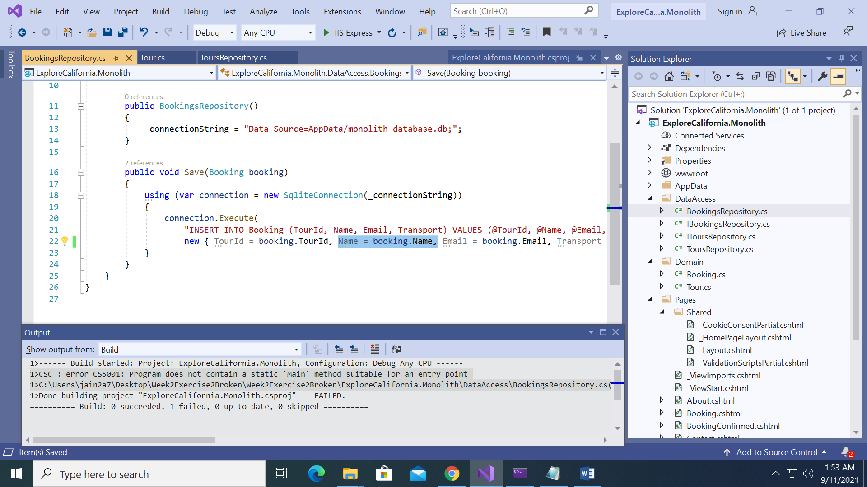

Corrected spelling of Main method

**public static void Main(string[] args)**

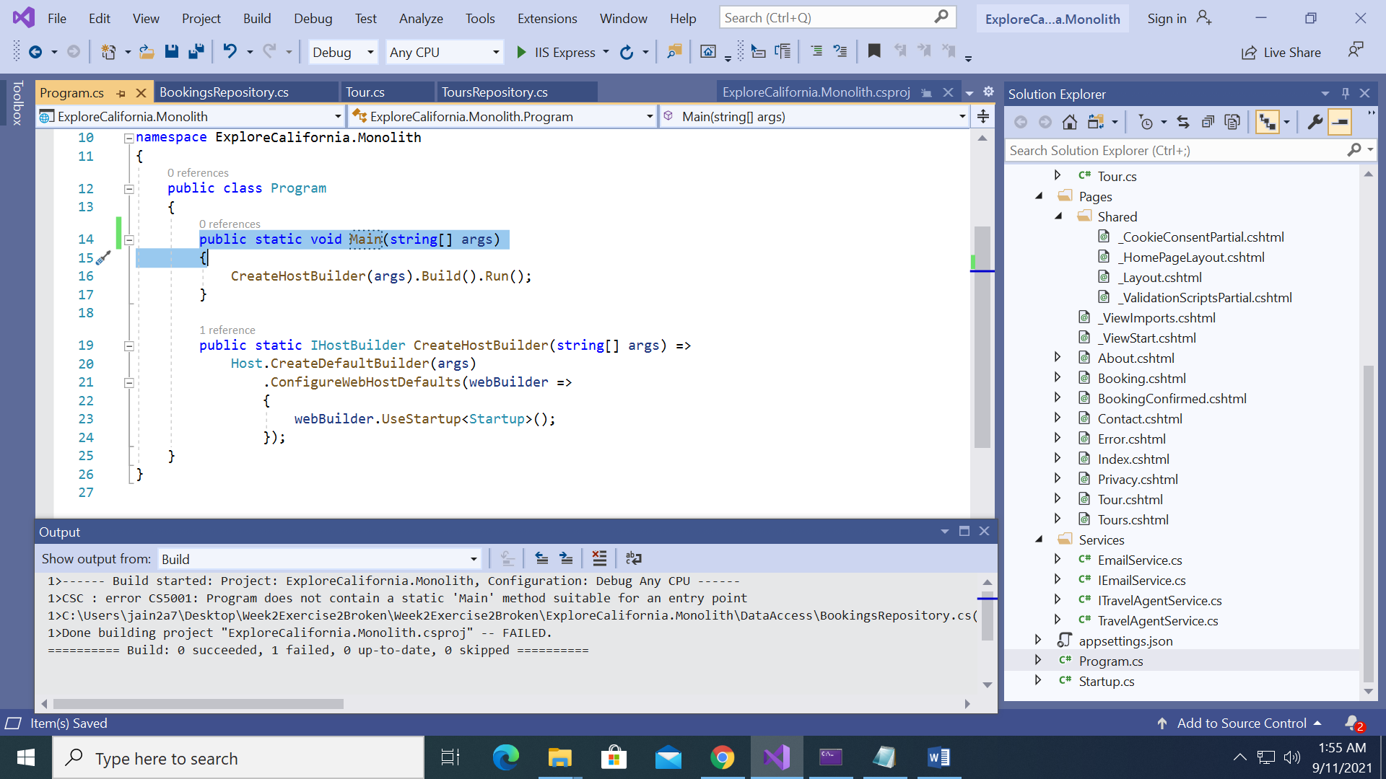

**Q-4** Checking of Index.cshtml

Ans. Uncommenting the Index.cshtml file

Final Page of the Application after fixing all errors

